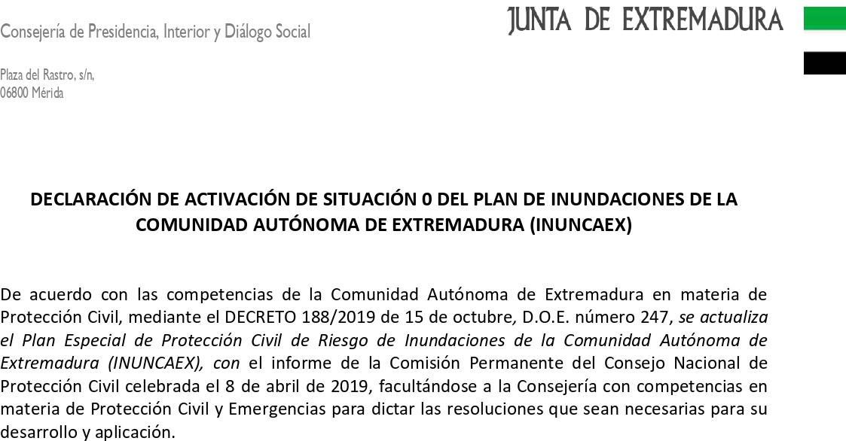

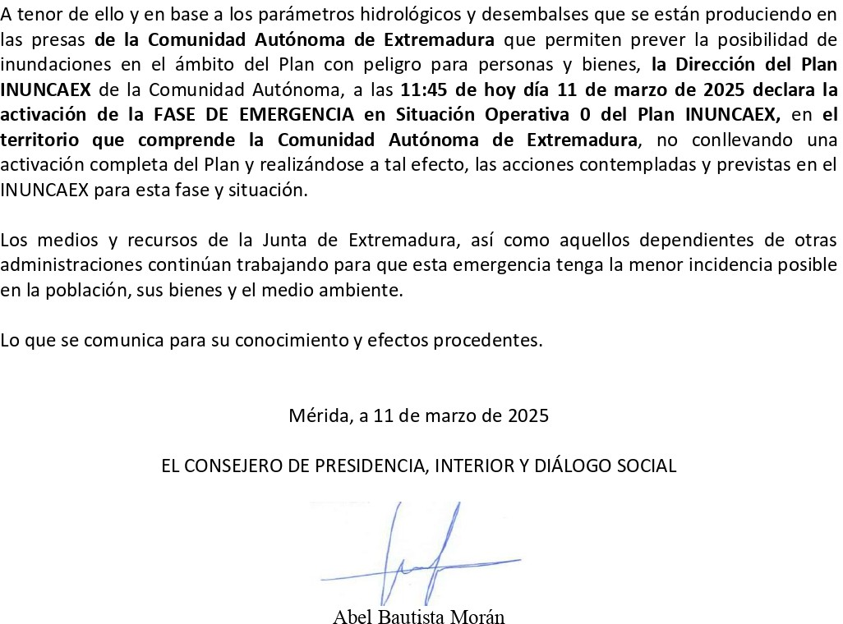

[Darme de baja](https://pnel.servicios-mail.com/unsuscribe/165381/a1c1c345638e1729bc00960400b3f73d/sC6EXX75j8WsNI2kRrNP9GU9ggkCWLgso/) | [Modificar mis datos](https://pnel.servicios-mail.com/newform/sC6EXX75j8WsNI2kRrNP9GU9ggkCWLgso/profile/)