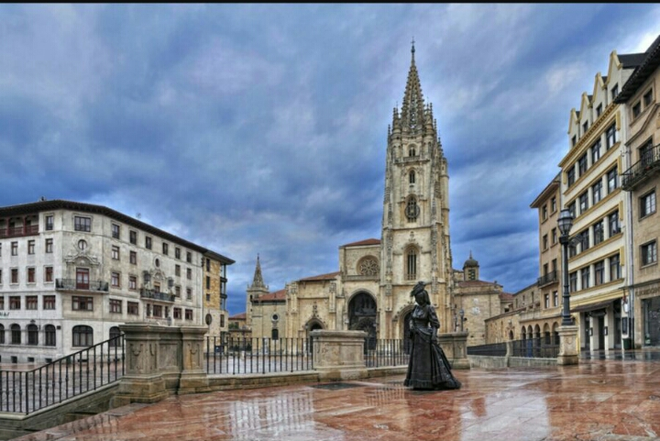

DEPARTURE ON NOVEMBER 9th
6 DAYS/5 NIGHTS.
ITINERARY
- 9th NOVEMBER: Iznate-Málaga-Madrid-Asturias. Iznate to Málaga by bus, then Málaga to Madrid by train (AVE), Madrid to Asturias by bus,lunch on route,arrival at hotel and dinner.
345€
- 10th NOVEMBER: Villaviciosa-Tazones-Aviles.
- 11th NOVEMBER: Luarca-Cudillero-oviedo.
- 12th NOVEMBER: Covadonga-Cangas de Onis-Ribadesella.
- 13th NOVEMBER: Gijón and free afternoon.
- 14th NOVEMBER: Bus journey Asturias-León-Madrid.
Train (AVE) Madrid-Málaga.

-ACCOMMODATION: HOTEL LOS ACEBOS ( ARRIONDAS).
-FULL BOARD.
-INCLUDING GUIDED TOURS.
-TRAVEL INSURANCE.
-80€ MORE, IF SINGLE ROOM
-REGISTRATION IN THE CITY HALL

