MEETING OF THE ELDERLY IN ALMACHAR

Next Saturday 22 ^{th} of October in ALMACHAR, there will be a meeting of the elderly.

Anyone over the age of 60 can register at the Town Hall, and a companion under this age if wife/husband.

Please confirm before Wednesday the 14th of October to Ana Díaz.

Cost: 10,00 € /person. Pay in Cajamar

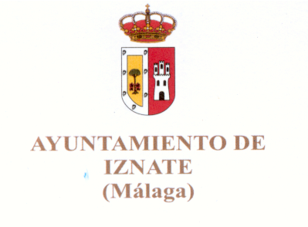
Telf. 952509776. Thank you.



